**Lung Diseases and Treatment**

**Cystic Fibrosis (CF)**

**What is Cystic Fibrosis and what causes it?**

Cystic Fibrosis is a progressive genetic lung disease that causes limited breathing ability over time and persistent lung infections. It affects a protein in the body called the CTFR protein and Cystic Fibrosis makes this protein faulty. Cystic Fibrosis is caused by mutations in a gene called the cystic fibrosis transmembrane conductance regulator (CFTR) gene. When the protein is not working it is not able to move chloride to cells surface. If the chloride is not moved to the surface, then the mucus in multiple organs becomes thick and sticky and causes blockages in the lungs.

**Symptoms of Cystic Fibrosis**

People suffering with Cystic Fibrosis can suffer from an array of symptoms including:

* Persistent coughing with phlegm
* Wheezing
* Shortness of breath
* Frequent lung infections like pneumonia or bronchitis
* Poor growth despite having a good appetite
* Delayed puberty or growth
* Salty skin
* 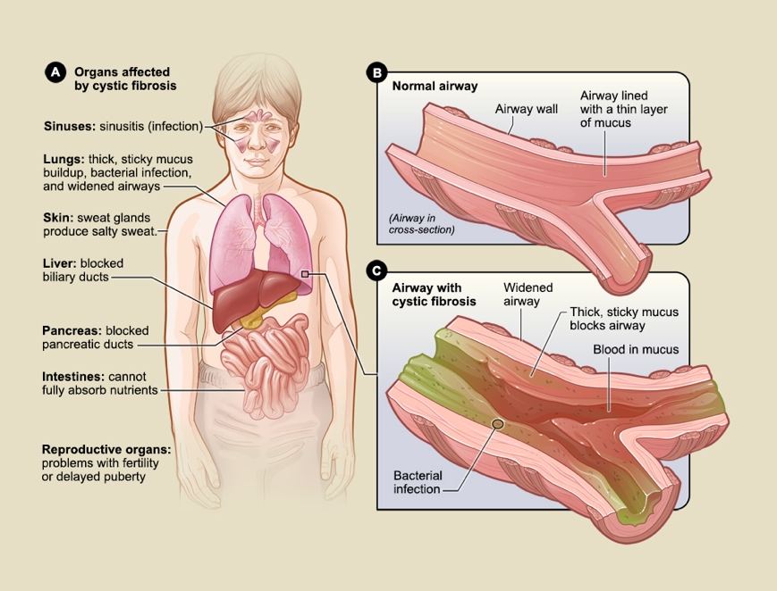Gastrointestinal symptoms
* Jaundice
* Low BMI
* Sinus infections

The diagram to the right shows the organs that Cystic Fibrosis affects and how they are affected.

**Treatment for Cystic Fibrosis**

CF severity differs from person to person, so treatments are different among patients. Treatment plans are developed for people suffering with CF. Each day people with Cystic Fibrosis have treatments that may consist of airway clearing; which helps to loosen and expel mucus build up in the lungs, Inhaled medicines; they’re inhaled through a nebulizer and contain antibiotics which opens airways or thins mucus, Pancreatic enzyme supplement; capsules that improve absorption of vital nutrients that are taken during most meals, fitness plan; to improve overall lung function and health, CFTR modulators; targets the underlying defect in the CFTR protein. New treatments are constantly being developed.

**Prevention of Cystic Fibrosis**

Due to Cystic Fibrosis being a genetic condition genetic testing can be performed to look for potential carriers of the mutated gene. However, CF is not preventable, people carrying the gene can choose not to have children.

**Tuberculosis (TB)**

**What is Tuberculosis and what causes it?**

Tuberculosis is a disease caused by an infection with the bacteria Mycobacterium tuberculosis. TB is found most commonly affecting a person’s lungs, but it can also affect different body parts and cause serious illness or death. Luckily tuberculosis can be cured with specific antibiotics. With tuberculosis there are active and inactive types, active TB means that the person is infected with the TB and their body cannot fight off the bacteria meaning they will have symptoms and are infectious. Inactive TB means that the person infected with the bacteria is able to fight off the TB, this is not infectious. Most people with TB have an inactive case and will likely never be infectious or feel any symptoms. TB spreads through the air when a person infected with Tuberculosis sneezes, coughs or speaks which makes the germs airborne. When others bring in the germs from the air then they could become infected.

**Symptoms of Tuberculosis**

People infected with the Tuberculosis bacteria can experience the following symptoms:

* Feeling tired or unwell
* They have a bad cough lasting around three weeks
* They may lose weight
* Loss of appetite
* Pain or swelling in infected area
* Night sweat
* Fevers
* Cough up bloody phlegm

**Treatment for Tuberculosis**

After being diagnosed through blood tests, sputum tests and chest x – rays you can begin treatments. For active Tuberculosis doctors will prescribe a combination of four drugs, isoniazid (INH), pyrazinamide (pms – Pyrazinamide, Tebrazid), rifampin (Rifadin, Rimactane) and ethambutol (Myambutol). These will generally be taken for six months as a first line of treatment. Strains of TB that are immune to these drugs will need different ones that have far more side effects.

**Prevention of Tuberculosis**

There is a Tuberculosis vaccine called Bacillus Calmette – Guérin (BCG) vaccine. This vaccine does not prevent TB, but it does allow a person exposed to it to possibly prevent the disease from progressing. If you know you have TB, you need to cover your mouth when sneezing or coughing and preferably wear a mask or isolate.

**References**

Health.nsw.gov.au. 2019. *Tuberculosis*. [online] Available at: <https://www.health.nsw.gov.au/Infectious/factsheets/Pages/tuberculosis.aspx> [Accessed 23 March 2021].

Publishing, H., 2019. *Tuberculosis - Harvard Health*. [online] Harvard Health. Available at: <https://www.health.harvard.edu/a_to_z/tuberculosis-a-to-z> [Accessed 23 March 2021].

Healthdirect.gov.au. 2020. *Tuberculosis*. [online] Available at: <https://www.healthdirect.gov.au/tuberculosis> [Accessed 23 March 2021].

Nhlbi.nih.gov. n.d. *Cystic Fibrosis | NHLBI, NIH*. [online] Available at: <https://www.nhlbi.nih.gov/health-topics/cystic-fibrosis#:~:text=find%20more%20information.-,Causes,instructions%20for%20the%20CFTR%20protein.> [Accessed 22 March 2021].

Cff.org. n.d. *About Cystic Fibrosis*. [online] Available at: <https://www.cff.org/What-is-CF/About-Cystic-Fibrosis/> [Accessed 22 March 2021].